Supplementary Information
Programmable macrophage-polarizing nanoparticles for MRI-guided early detection and treatment of pulmonary metastases
Meiju Sui^{1,2}, Kairu Xie^{1,2}, Yingying Luo^{1,2}, Haiqiang Wang^{1,2}, Hao Sheng¹, Sen Yue^{1,2}, Xiaoxun Liu^{1,2}, Sha Li^{1,2}, Jung Soo Suk³, Shizhen Chen^{1,2,4}, Daiqin Chen^{1,2}* & Xin Zhou^{1,2,4}*
¹State Key Laboratory of Magnetic Resonance Spectroscopy and Imaging, National Center for Magnetic Resonance in Wuhan, Wuhan Institute of Physics and Mathematics, Innovation Academy for Precision Measurement Science and Technology, Chinese Academy of Sciences, Wuhan 430071, P. R. China
²University of Chinese Academy of Sciences, Beijing 100049, P. R. China
³Department of Neurosurgery and Medicine Institute for Neuroscience Discovery (UM-MIND), University of Maryland School of Medicine, 670 West Baltimore Street, HSR III Rm 9106, Baltimore, MD 21201, USA
⁴Key Laboratory of Biomedical Engineering of Hainan Province, School of Biomedical Engineering, Hainan University, Haikou 570228, P. R. China
*Correspondence:
Daiqin Chen
chendychin@apm.ac.cn
Xin Zhou
xinzhou@wipm.ac.cn

Fig. S1. The X-ray photoelectron spectroscopy (XPS) spectra of CQM NPs. The XPS analysis was performed on CQM NPs synthesized in three independent batches.
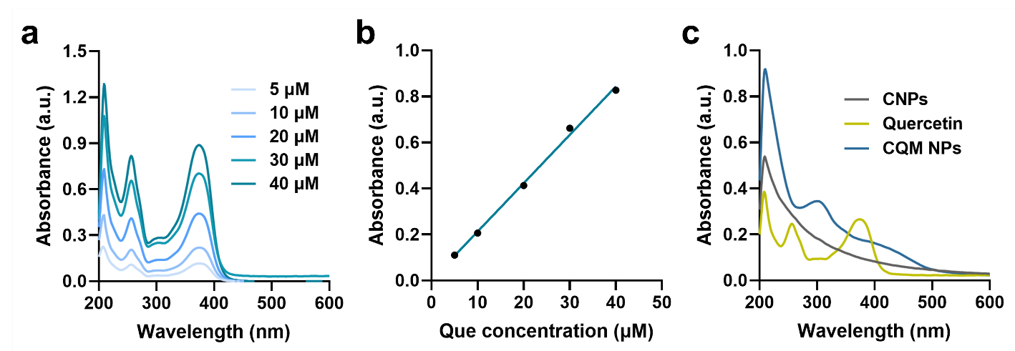
Fig. S2. (a) UV-vis absorption spectra of quercetin with different concentrations. (b) The standard curve fitted with quercetin absorbance versus concentration. (c) UV-vis absorption spectra of CNPs, quercetin and CQM NPs.
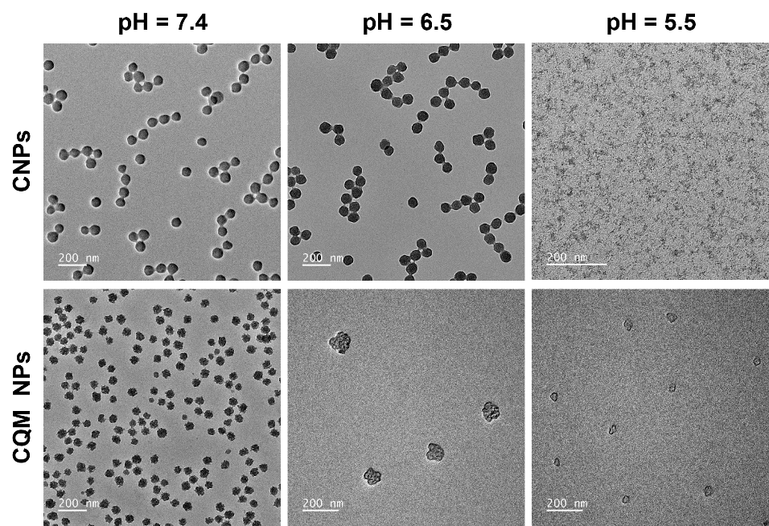
Fig. S3. TEM images of CNPs and CQM NPs under different pH (7.4, 6.5 and 5.5) conditions.
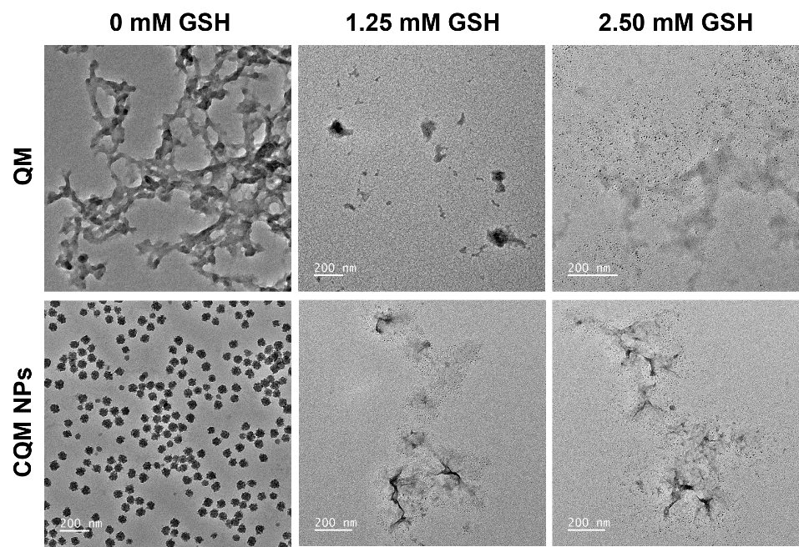
Fig. S4. TEM images of QM and CQM NPs exposed to different GSH concentrations (0, 1.25, and 2.50 mM).
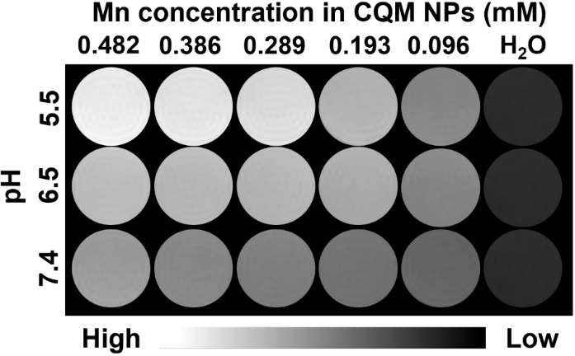
Fig. S5. T₁-weighted MRI images of CQM NPs under different pH (7.4, 6.5, and 5.5) conditions.
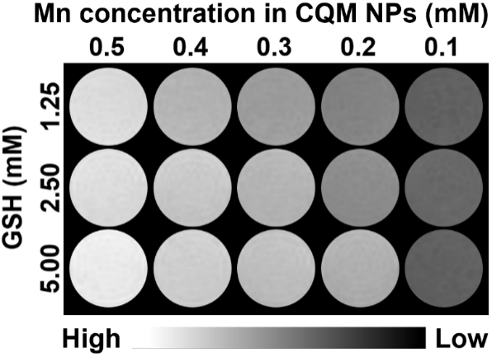
Fig. S6. T₁-weighted MRI images of CQM NPs exposed to different GSH concentrations (0, 1.25, and 2.50 mM).
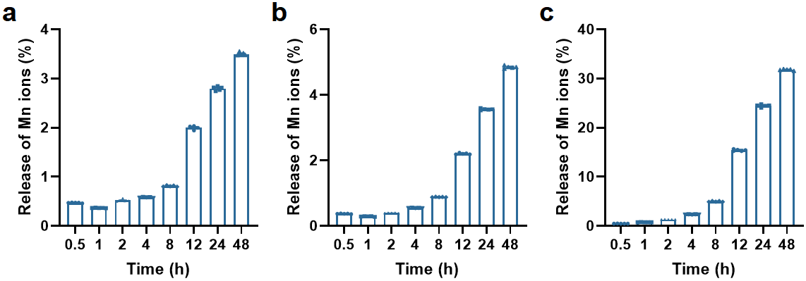
Fig. S7. Mn ions release profiles of CQM NPs under pH 6.5 (a), pH 5.5 (b), and 2.50 mM GSH (c) conditions. Data are presented as mean ± SEM (n = 5).
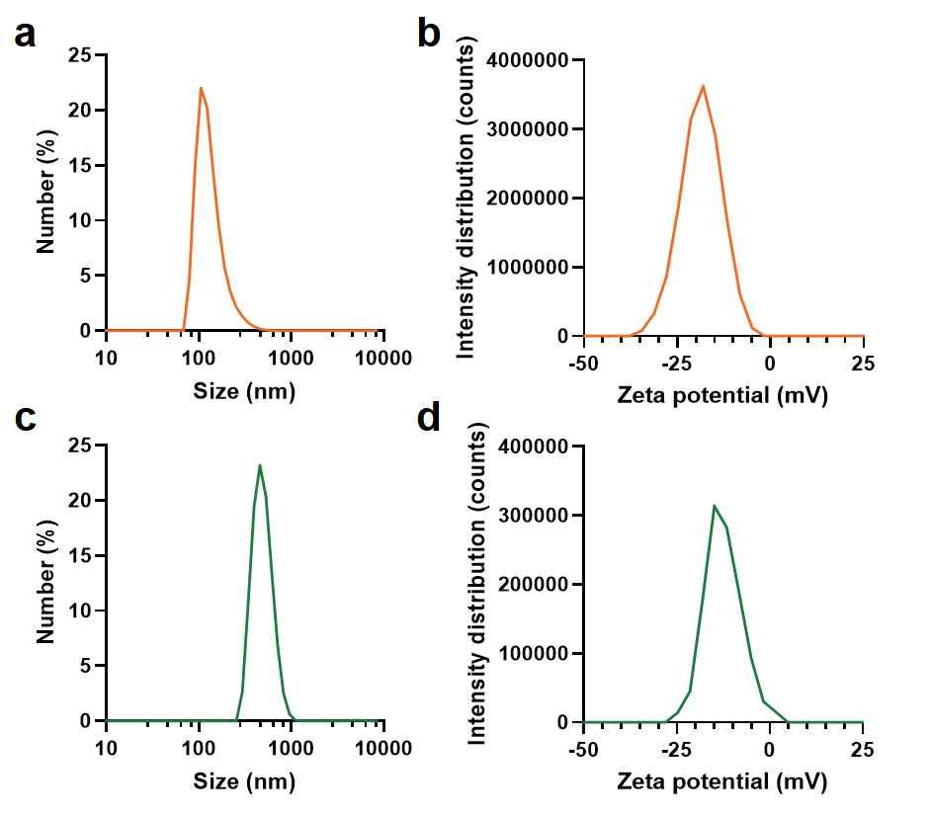
Fig. S8. Size distribution (a) and zeta potential (b) of PQM NPs. Size distribution (c) and zeta potential (d) of CDM NPs.
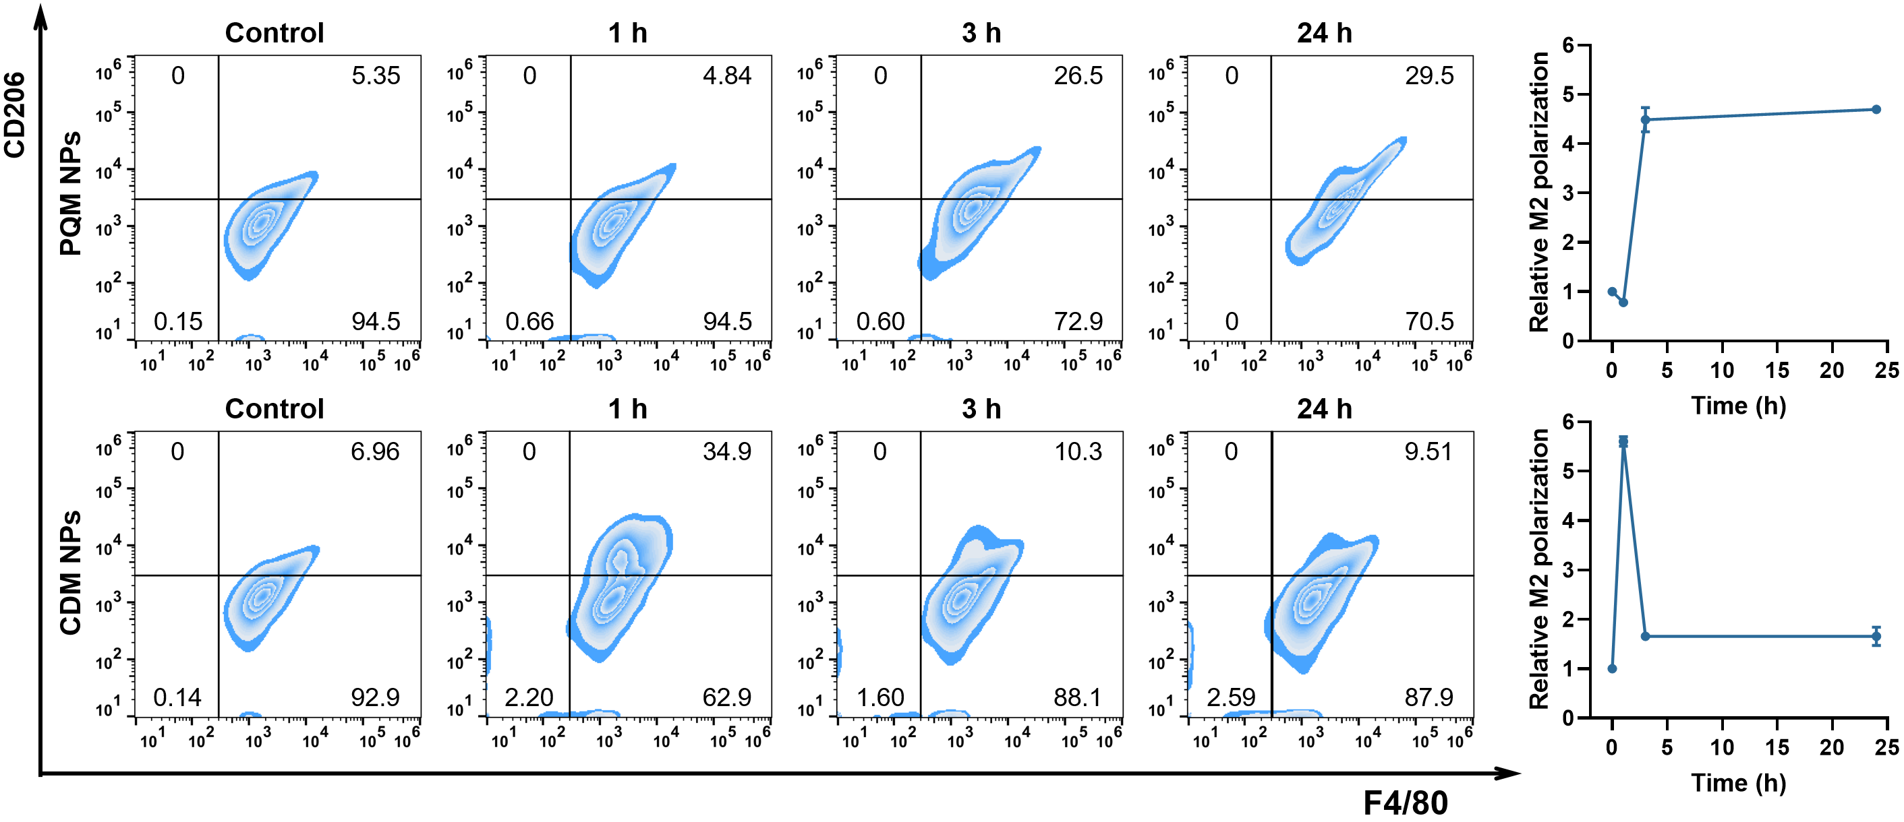
Fig. S9. FC profiles and quantification of M2 polarization in RAW264.7 cells after treatment with PQM NPs and CDM NPs over time. Data are presented as the mean ± SEM (n = 3).
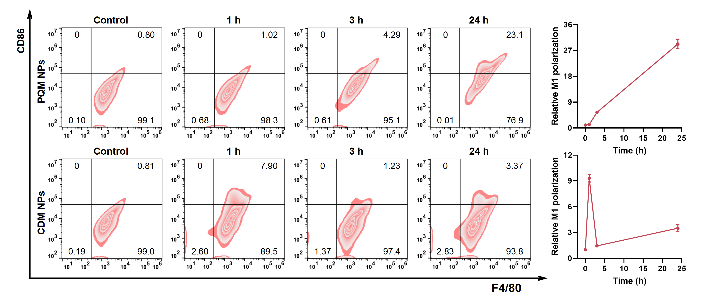
Fig. S10. FC profiles and quantification of M1 polarization in RAW264.7 cells after treatment with PQM NPs and CDM NPs over time. Data are presented as the mean ± SEM (n = 3).
Fig. S11. H&E staining of the main organs from healthy mice received CQM NPs via different administrations. Scale bar represents 100 μm.

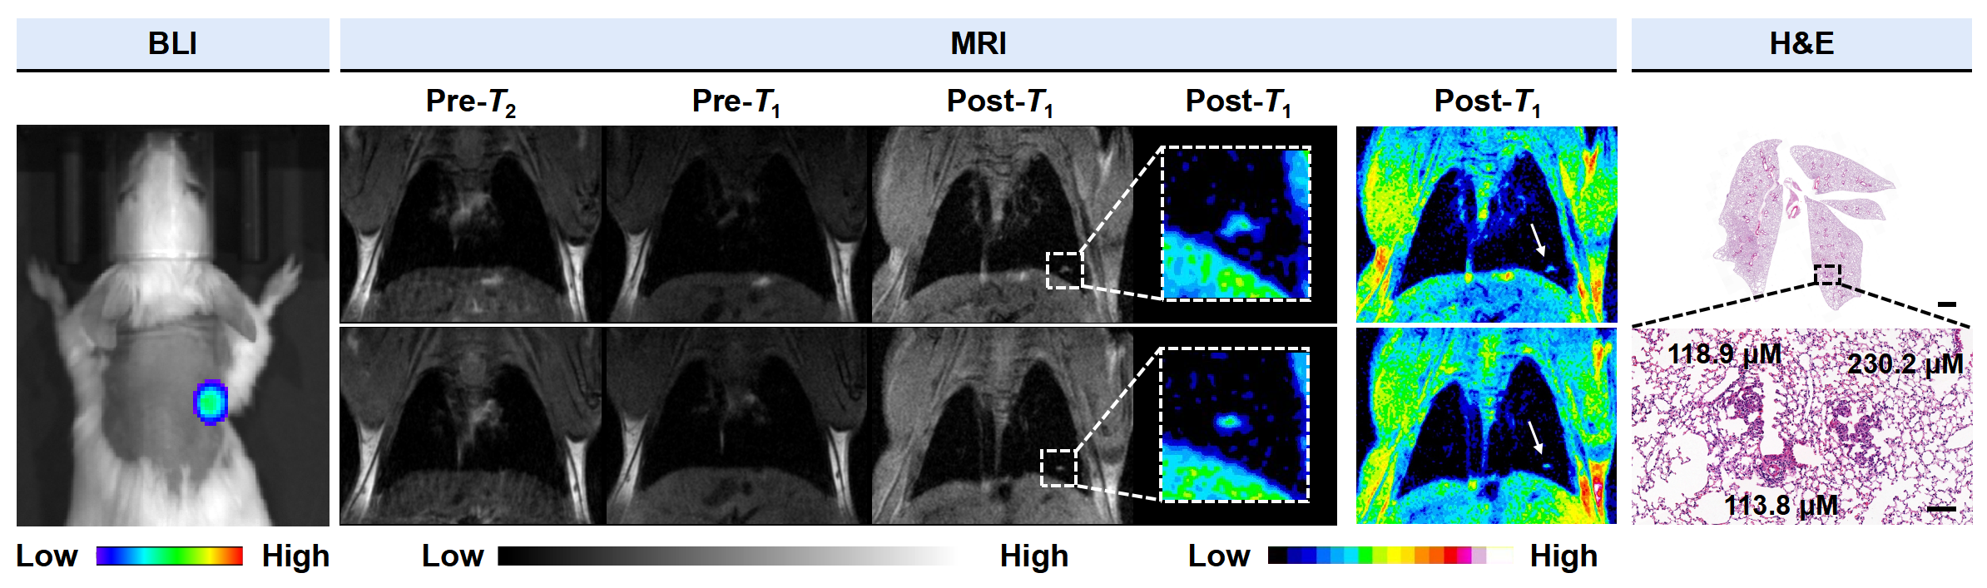
Fig. S12. BLI, T₂- and T₁-weighted MRI, and H&E staining of the lung of mice bearing pulmonary metastatic tumor as small as 0.11 mm pre- and post-administrated of CQM NPs. Scale bars represent 1 mm (top) and 100 μm (bottom), respectively.
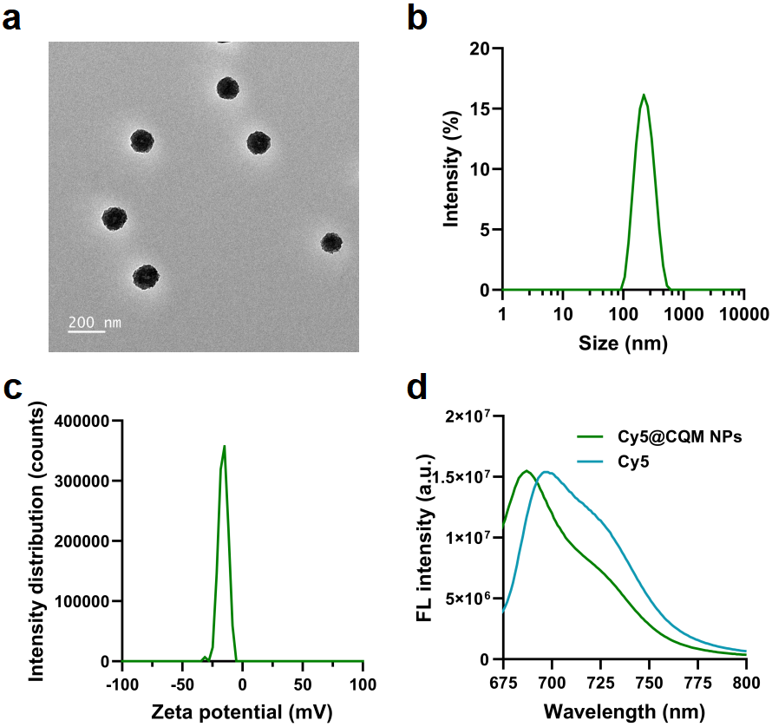
Fig. S13. TEM image (a), size distribution (b), zeta potential (c), and fluorescence spectrum (d) of Cy5@CQM NPs.
Fig. S14. Cell viability of RAW264.7 cells incubated with CQM NPs at different concentrations. Data are presented as the mean ± SEM (n = 4). Statistical significance was calculated in GraphPad Prism. * P < 0.05; ** P < 0.01; *** P < 0.001; **** P < 0.0001; ns, not significant.
Fig. S15. The cytosolic Mn contents in RAW264.7 cells incubated with CQM NPs (C_{Mn} = 0.1 mM) at different time points. Data are presented as the mean ± SEM (n = 3).

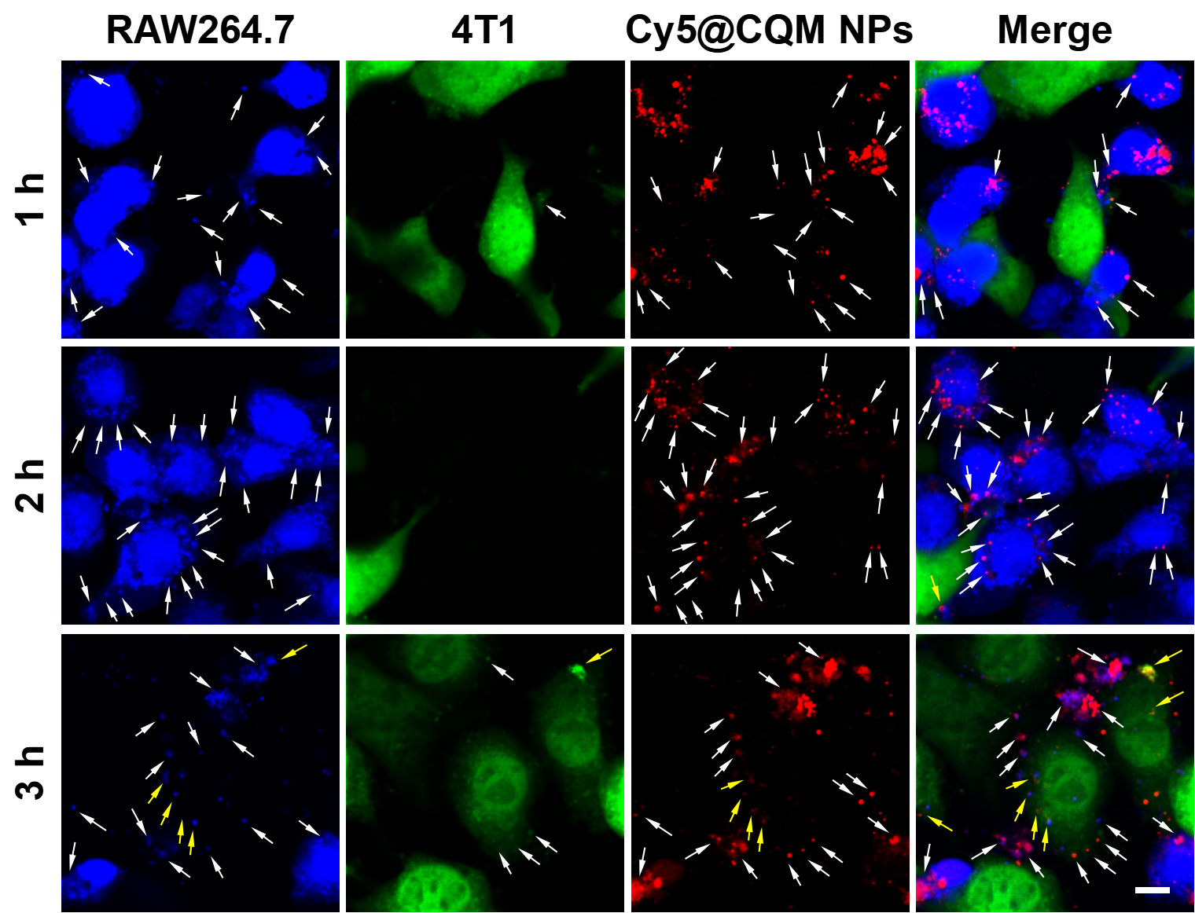
Fig. S16. The CLSM images of 4T1 cells incubated with RAW264.7 cells pretreated with CQM NPs at various time points. The white arrows indicate small vesicles containing Cy5@CQM NPs, formed by direct budding from the macrophage membrane. The yellow arrows indicate Cy5@CQM NPs successfully delivered into 4T1 cells. Scale bar represents 50 μm.
Fig. S17. The cytosolic Mn contents in 4T1 cells after incubation with RAW264.7 cells pre-treated with CQM NPs, PQM NPs, and CDM NPs for 3 hours. Data are presented as the mean ± SEM (n = 3). Statistical significance was calculated in GraphPad Prism. * P < 0.05; ** P < 0.01; *** P < 0.001; **** P < 0.0001; ns, not significant.
Fig. S18. CLSM images of 4T1 cells incubated with RAW264.7 cells pretreated with CQM NPs at different time points. Scale bar represents 50 μm.
Fig. S19. CLSM images of 4T1 cells incubated with CQM NPs at different time points. Fluorescence assignments: BCECF (green). Scale bar represents 50 μm.

Fig. S20. CLSM images of 4T1 cells incubated with CQM NPs at different time points. Scale bar represents 50 μm.
Fig. S21. Cell viability of 4T1 cells after incubation with various concentrations of CQM NPs. Data are presented as the mean ± SEM (n = 6).
Fig. S22. Gene set enrichment analysis (GSEA) showed the positive enrichment of the Interferon-α response (a) and Interferon-γ response (b) pathway in the CQM NPs group compared to the control group. The top 5 differentially expressed genes (DEGs) of the Interferon-α response (c) and Interferon-γ response (d) pathway.

Fig. S23. Quantification of Mn contents in the lungs of mice with different administration routes. Data are presented as the mean ± SEM (n = 4). Statistical significance was calculated in GraphPad Prism. * P < 0.05; ** P < 0.01; *** P < 0.001; **** P < 0.0001; ns, not significant.
Fig. S24. Quantification of Mn contents in the blood of mice with different administration routes. Data are presented as the mean ± SEM (n = 4). Statistical significance was calculated in GraphPad Prism. * P < 0.05; ** P < 0.01; *** P < 0.001; **** P < 0.0001; ns, not significant.
Fig. S25. Body weight change curves of metastatic tumor-bearing mice with different treatments in the anti-metastasis study. Data are presented as the mean ± SEM (n = 5).
Fig. S26. Photographs of main organs and metastatic tumors from mice with different treatments after anti-metastasis study (n = 5).
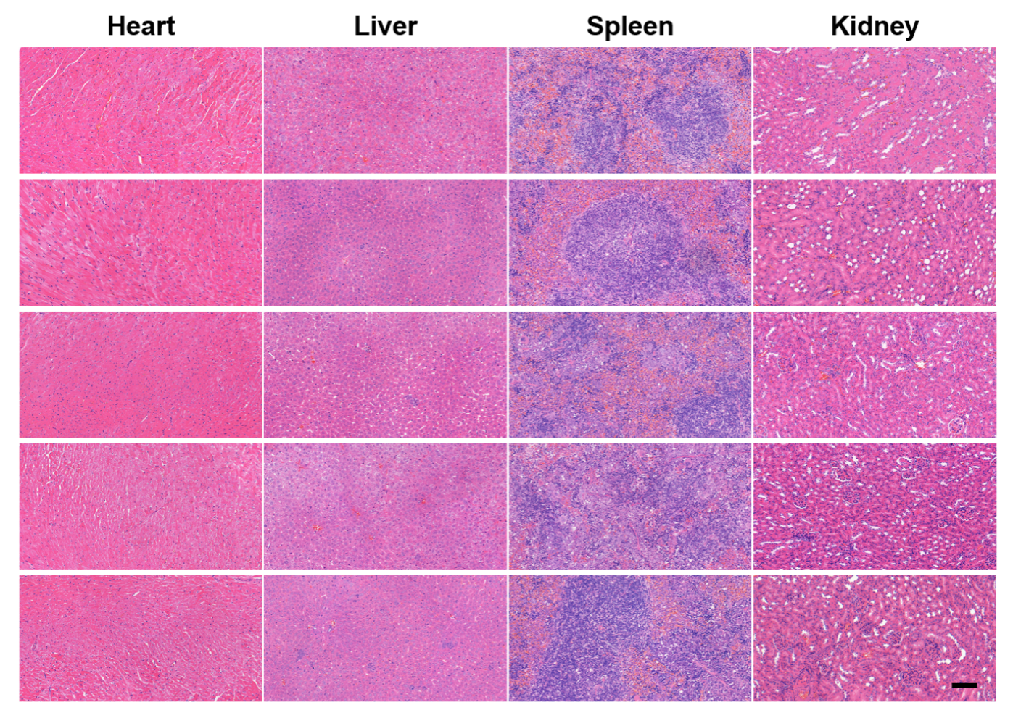
Fig. S27. H&E staining of main organs from mice treated with saline in the anti-metastasis study (n = 5). Scale bar represents 100 μm.
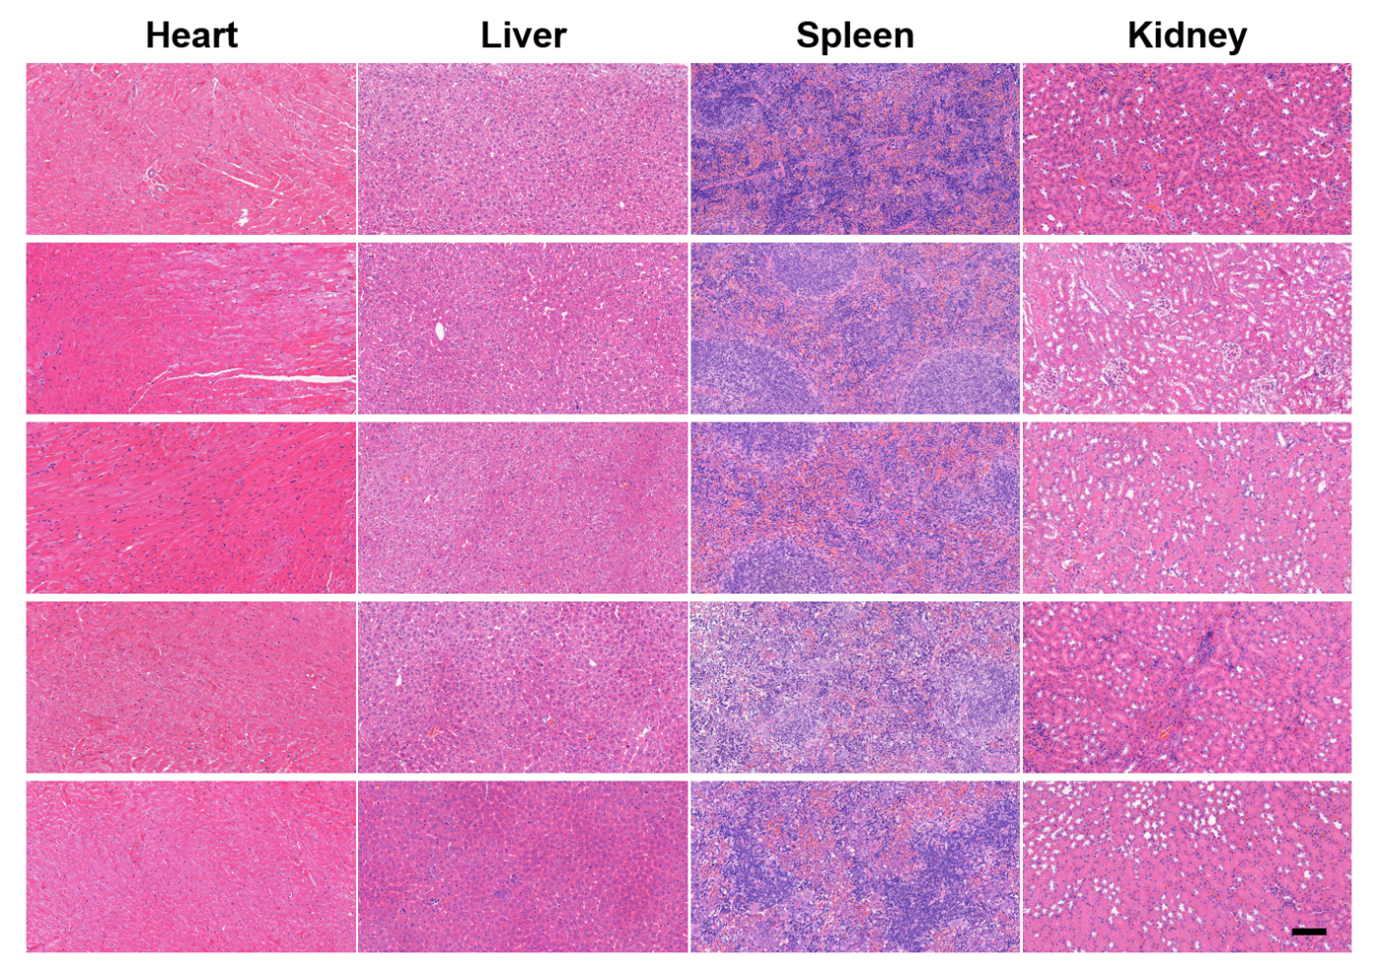
Fig. S28. H&E staining of main organs from mice treated with CQM NPs in the anti-metastasis study (n = 5). Scale bar represents 100 μm.

Fig. S29. The cumulative survival of mice receiving different treatments in the metastasis prophylaxis study (n = 5).
Fig. S30. The body weight change curves of mice with different treatments during the metastasis prophylaxis study. Data are presented as the mean ± SEM (n = 5).
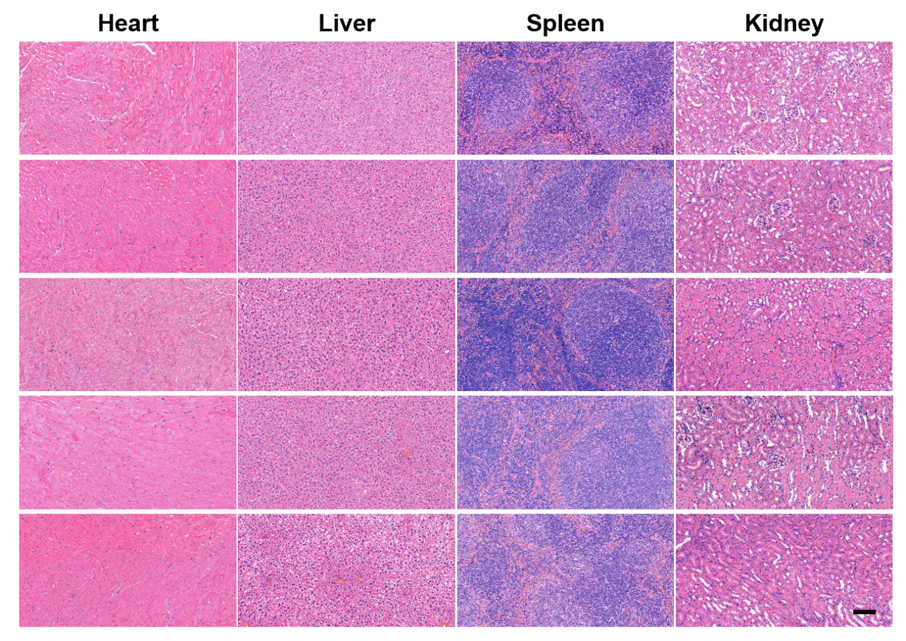
Fig. S31. H&E staining of main organs from mice treated with saline after the metastasis prophylaxis study (n = 5). Scale bar represents 100 μm.
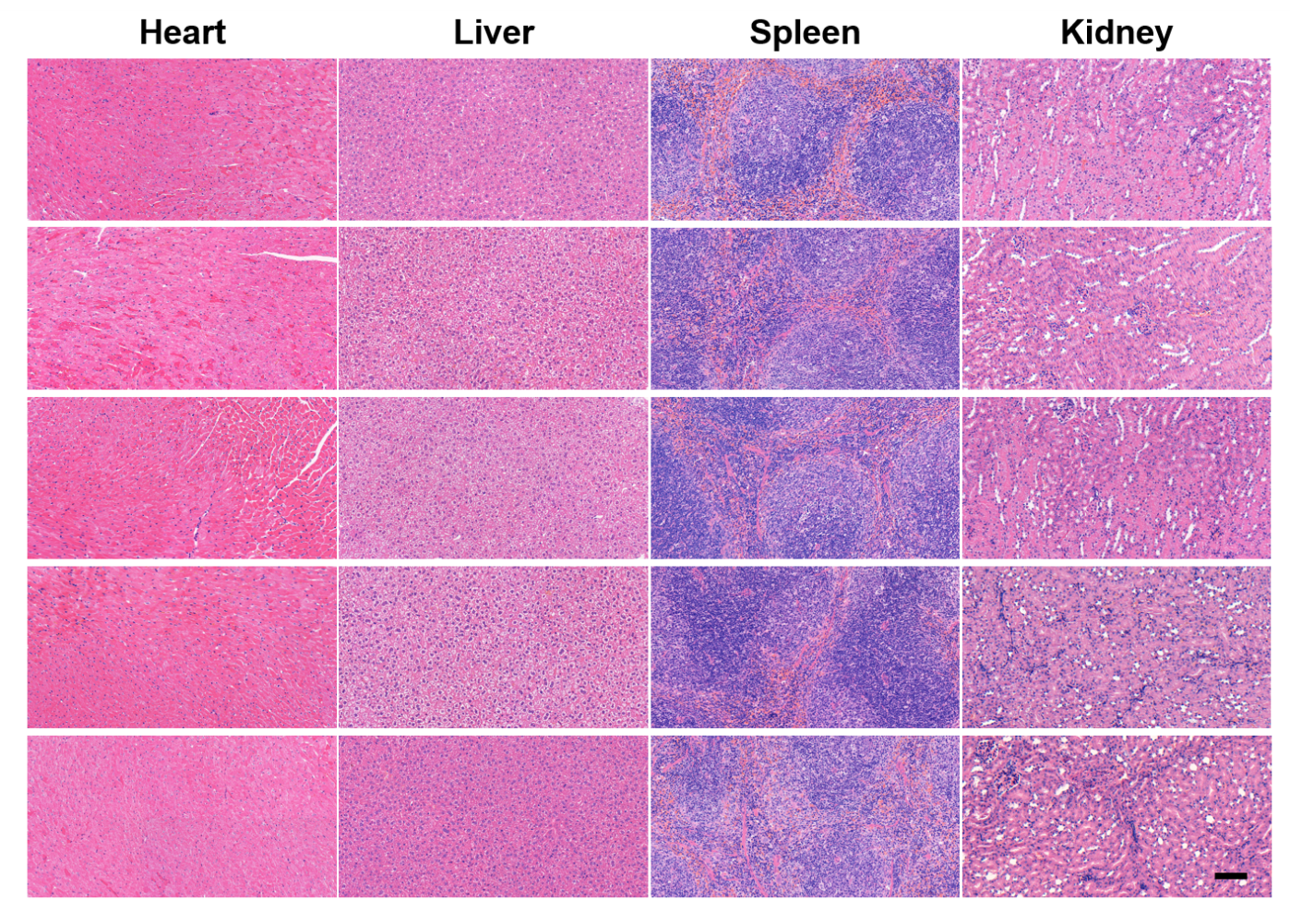
Fig. S32. H&E staining of main organs from mice treated with CQM NPs after the metastasis prophylaxis study (n = 5). Scale bar represents 100 μm.
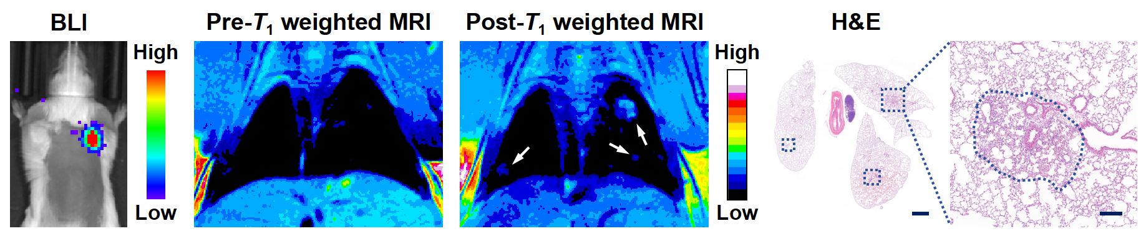
Fig. S33. BLI, MRI and H&E staining of metastatic tumor-bearing mice with intratracheal administration of CQM NPs. The white arrows indicate T₁-weighted MRI signals of lung metastases and the blue dashed square frames indicate pulmonary metastases. Scale bars in low and high magnified H&E images represent 1 mm and 200 μm, respectively.

Table S1. The parameters which impact the synthesis of CQM NPs. The synthesis of CQM NPs was carried out in at least three independent experimental runs using different procedures.
- Using CNPs as the synthesis templates | 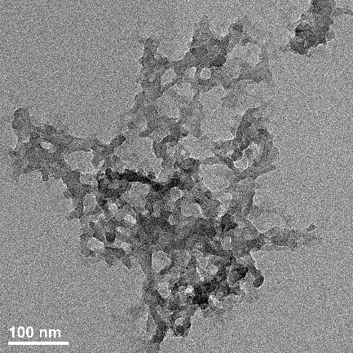 | When CNPs were not used as the templates, the QM complexes were without defined morphology.
- The sequence of addition of MnCl₂ and quercetin solution | 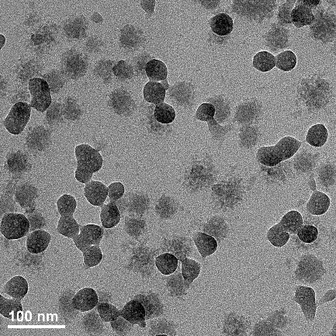 | When MnCl₂ solution and quercetin solution were added in an improper order, quercetin and Mn²⁺ self-assembled into QM cpmplexes rather than being coated on CNPs.
- The pH value of the reaction system | 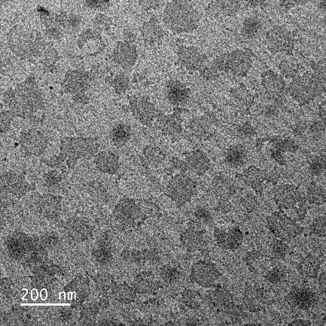 | When the pH value was lower than 7, the CNPs would dissolve prematurely. Meanwhile, quercetin and Mn²⁺ would not self-assemble into QM complexes，either.
- The addition rate of MnCl₂ to quercetin solution | 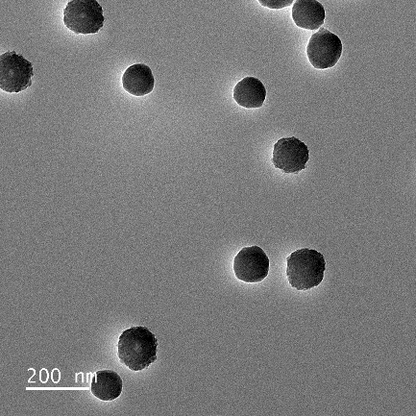 | Too fast addition rate led to inadequate coating of QM to CNPs.

Table S2. The element content corresponding to TEM mapping of CQM NPs. Elemental mapping analysis via TEM-EDS was performed on CQM NPs synthesized in three independent batches to quantify their spatial elemental distribution.
Element | Line type | X ray peak | Weight percentage (%) | Atomic percentage (%)
C | K | 277 eV | 81.36 | 86.81
O | K | 525 eV | 15.09 | 12.08
Ca | L | 341 eV | 3.20 | 1.02
Mn | L | 637 eV | 0.35 | 0.08
Total content |  |  | 100 | 100

Table S3. The blood routine analysis of healthy mice received CQM NPs administration via i.v. and i.t. Data are presented as the mean ± SEM (n = 3).
Healthy mice | Untreated | i.v. | i.t.
WBC (10⁹/L) | 5.00 ± 0.50 | 5.47 ± 1.16 | 4.60 ± 1.02
RBC (10¹²/L) | 8.98 ± 1.80 | 10.29 ± 0.57 | 10.19 ± 0.58
HGB (g/L) | 178.67 ± 5.84 | 168.67 ± 9.60 | 167.67 ± 13.17
HCT (%) | 48.23 ± 9.26 | 52.70 ± 4.40 | 54.43 ± 3.86
MCV (fL) | 54.00 ± 0.60 | 51.13 ± 1.52 | 53.40 ± 0.70
MCH (pg) | 22.13 ± 5.83 | 16.37 ± 0.12 | 16.37 ± 0.38
MCHC (g/L) | 306.67 ± 1.86 | 321.00 ± 8.96 | 307.33 ± 3.28
RDW (%) | 14.60 ± 0 20 | 15.27 ± 0.43 | 13.90 ± 0.52

Table S4. The blood chemistry analysis of healthy mice received CQM NPs administration via i.v. and i.t. Data are presented as the mean ± SEM (n = 3).
Healthy mice | Untreated | i.v. | i.t.
ALT (U/L) | 34.88 ± 2.63 | 45.56 ± 1.17 | 46.45 ± 0.43
AST (U/L) | 118.65 ± 3.92 | 132.01 ± 2.16 | 130.15 ± 3.73
TBIL (μmol/L) | 11.77 ± 0.90 | 10.01 ± 0.93 | 13.53 ± 1.16
DBIL (μmol/L) | 4.92 ± 0.79 | 3.56 ± 0.57 | 3.97 ± 0.96
ALB (g/L) | 36.58 ± 1.01 | 35.49 ± 0.35 | 38.85 ± 1.13
ALP (U/L) | 228.77 ± 6.51 | 202.91 ± 3.00 | 245.67 ± 5.97
γ-GT (U/L) | 5.51 ± 0.05 | 5.51 ± 0.04 | 5.43 ± 0.04
TBA (μmol/L) | 9.91 ± 1.29 | 6.67 ± 0.90 | 7.60 ± 1.03
UREA (mmol/L) | 27.06 ± 1.20 | 20.34 ± 0.39 | 27.56 ± 0.52
CREA (μmol/L) | 59.91 ± 13.46 | 45.17 ± 3.13 | 49.00 ± 5.54
UA (μmol/L) | 269.36 ± 14.48 | 403.60 ± 5.82 | 281.24 ± 7.51

Table S5. The blood routine analysis of pulmonary metastasis-bearing mice received anti-metastasis therapy based on CQM NPs administration. Data are presented as the mean ± SEM (n = 5).
Pulmonary metastases-bearing mice | Control | CQM NPs
WBC (10⁹/L) | 83.93 ± 18.84 | 22.92 ± 8.02
RBC (10¹²/L) | 9.67 ± 0.60 | 9.18 ± 0.15
HGB (g/L) | 166.00 ± 9.99 | 154.20 ± 2.20
HCT (%) | 45.98 ± 3.03 | 42.80 ± 0.68
MCV (fL) | 47.60 ± 0.36 | 46.66 ± 0.21
MCH (pg) | 17.13 ± 0.15 | 16.74 ± 0.14
MCHC (g/L) | 361.00 ± 5.28 | 359.40 ± 2.42
RDW (%) | 14.75 ± 0.31 | 15.16 ± 0.31

Table S6. The blood chemistry analysis of pulmonary metastasis-bearing mice received anti-metastasis therapy based on CQM NPs administration. Data are presented as the mean ± SEM (n = 5).
Pulmonary metastases-bearing mice | Control | CQM NPs
ALT (U/L) | 23.42 ± 3.30 | 36.71 ± 10.09
AST (U/L) | 139.96 ± 11.26 | 140.63 ± 9.90
TBIL (μmol/L) | 12.62 ± 1.27 | 12.72 ± 0.82
DBIL (μmol/L) | 5.37 ± 0.63 | 5.81 ± 0.76
ALB (g/L) | 28.51 ± 1.12 | 29.07 ± 0.65
ALP (U/L) | 61.45 ± 16.39 | 68.37 ± 5.39
γ-GT (U/L) | 1.66 ± 0.03 | 1.68 ± 0.02
TBA (μmol/L) | 5.83 ± 1.60 | 5.66 ± 0.52
UREA (mmol/L) | 20.60 ± 2.22 | 19.32 ± 2.88
CREA (μmol/L) | 19.64 ± 1.79 | 22.15 ± 1.45
UA (μmol/L) | 276.07 ± 27.69 | 237.85 ± 40.19
Table S7. The blood routine analysis of mice received metastasis prophylaxis therapy based on CQM NPs administration. Data are presented as the mean ± SEM (n = 5).
Pulmonary metastases-bearing mice | Control | CQM NPs
WBC (10⁹/L) | 7.58 ± 2.38 | 5.92 ± 1.20
RBC (10¹²/L) | 9.80 ± 0.71 | 10.05 ± 0.19
HGB (g/L) | 164.40 ± 7.60 | 161.20 ± 3.47
HCT (%) | 50.88 ± 4.13 | 52.12 ± 1.19
MCV (fL) | 51.82 ± 0.62 | 51.90 ± 0.29
MCH (pg) | 16.90 ± 0.68 | 15.98 ± 0.07
MCHC (g/L) | 327.20 ± 15.48 | 308.80 ± 1.83
RDW (%) | 14.52 ± 1.06 | 13.58 ± 0.23

Table S8. The blood chemistry analysis of mice received metastasis prophylaxis therapy based on CQM NPs administration. Data are presented as the mean ± SEM (n = 5).
Pulmonary metastases-bearing mice | Control | CQM NPs
ALT (U/L) | 134.57 ± 12.78 | 93.10 ± 12.70
AST (U/L) | 466.71 ± 103.48 | 276.43 ± 28.02
TBIL (μmol/L) | 15.17 ± 1.32 | 17.83 ± 2.57
DBIL (μmol/L) | 4.89 ± 0.85 | 3.88 ± 1.13
ALB (g/L) | 35.17 ± 1.10 | 37.38 ± 0.84
ALP (U/L) | 135.30 ± 14.96 | 223.99 ± 20.13
γ-GT (U/L) | 2.62 ± 0.02 | 2.64 ± 0.03
TBA (μmol/L) | 7.33 ± 0.74 | 6.54 ± 0.15
UREA (mmol/L) | 22.89 ± 1.83 | 26.62 ± 1.08
CREA (μmol/L) | 20.22 ± 1.00 | 22.66 ± 1.65
UA (μmol/L) | 205.61 ± 48.58 | 365.00 ± 25.99

